Solve this 3 Law of Newton physics problem correctly:
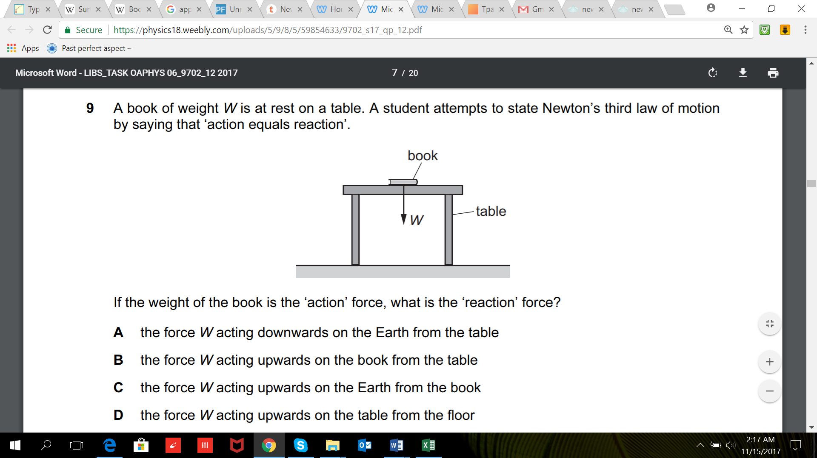
C is the correct answer because the forces must be of the same type.

This is from paper 9702_s17_qp_12.pdf
https://physics18.weebly.com/uploads/5/9/8/5/59854633/9702_s17_qp_12.pdf
https://physics18.weebly.com/uploads/5/9/8/5/59854633/9702_s17_ms_12.pdf

